***Charting the course of innovation: A startup analysis 1.1.1 INDRODUCTION***

* 1. ***Overview***

***A Startup is a company in the early stages of development that is set up by one or several people to enter an exciting market with unique products or services. Startup companies often face insufficient capital to fund their business operations to be at the same level as already established companies.***

***1.2 Purpose***

***For startups, market analysis is essential because it allow them to decide the type of marketing strategy that will reach and resonate with the most people in their target demographic. They can then allocate their funds in such a way that their choices are supported.***

1. ***Problem Definition & Design Thinking***

2.1 Empathy Map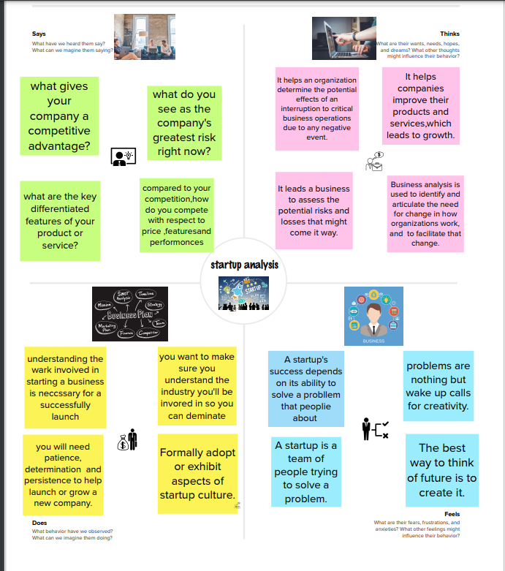

* 1. ***Ideation & Brainstorm Map***

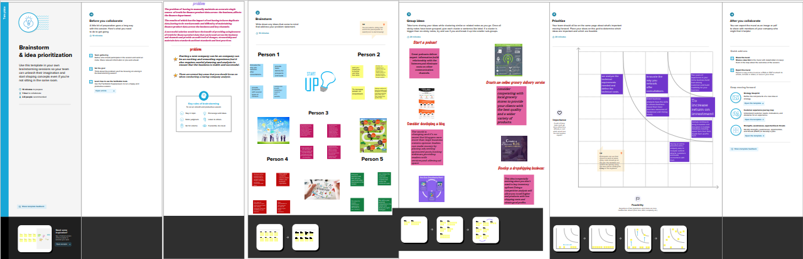

3.Result

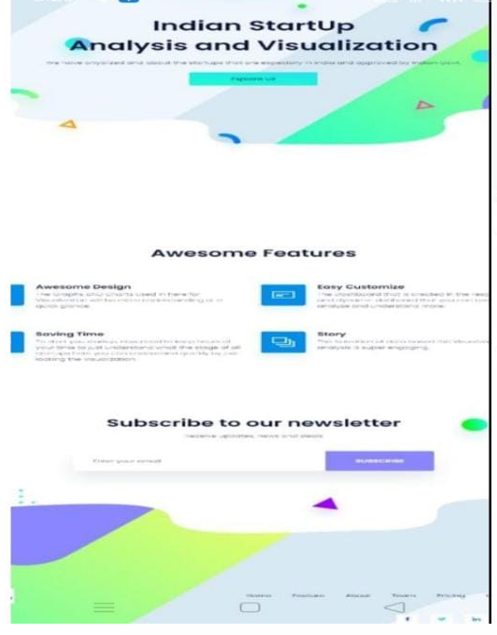

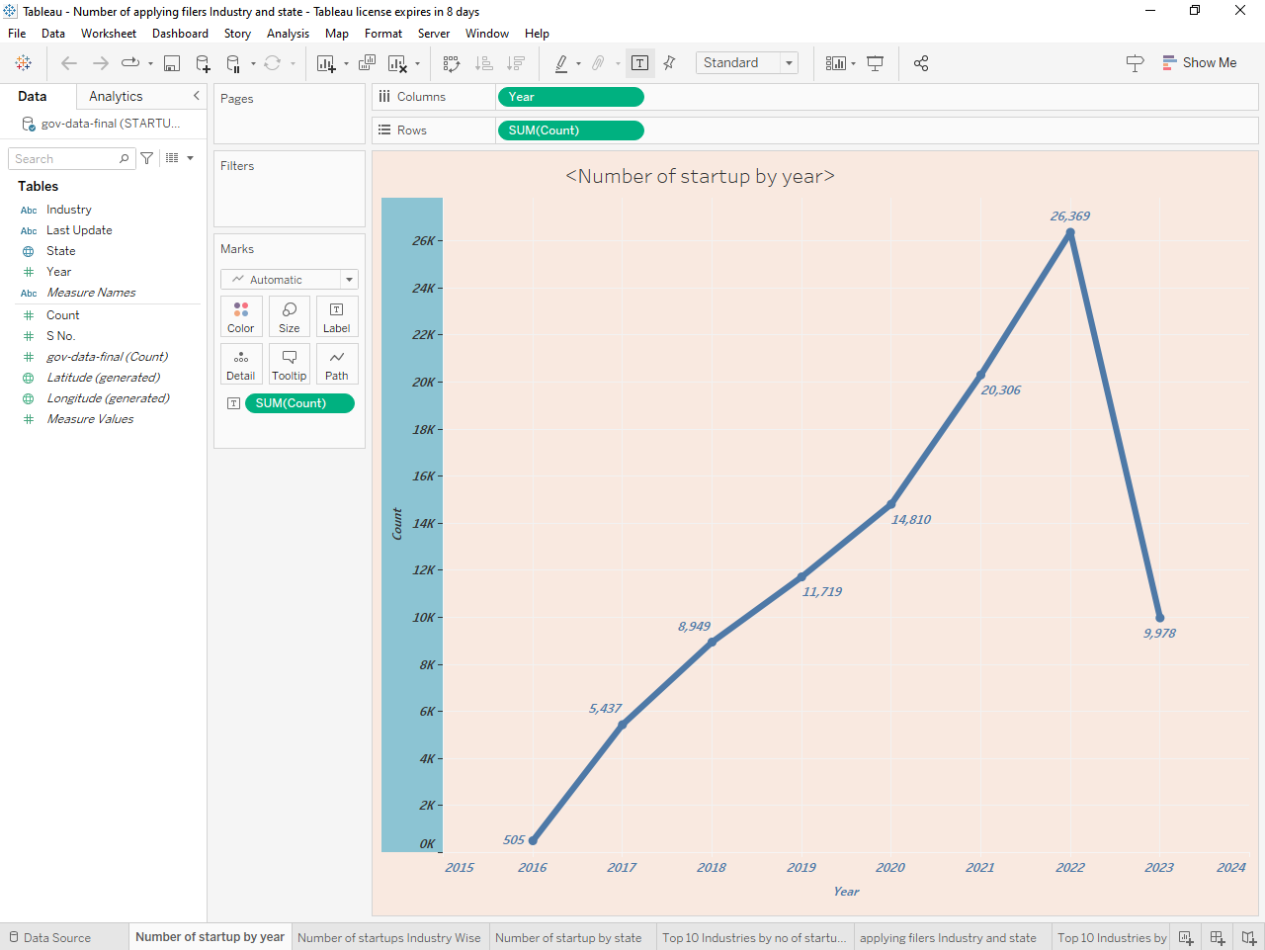

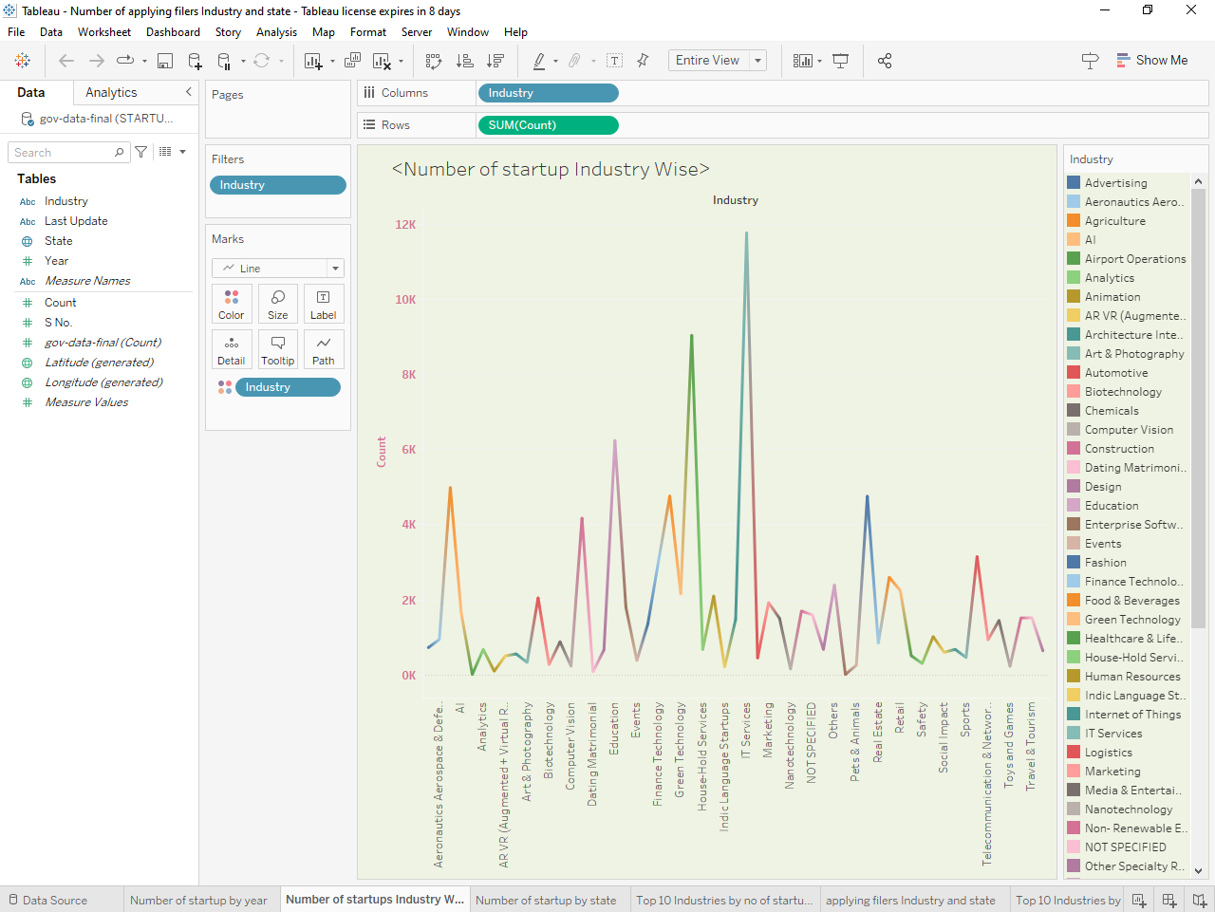

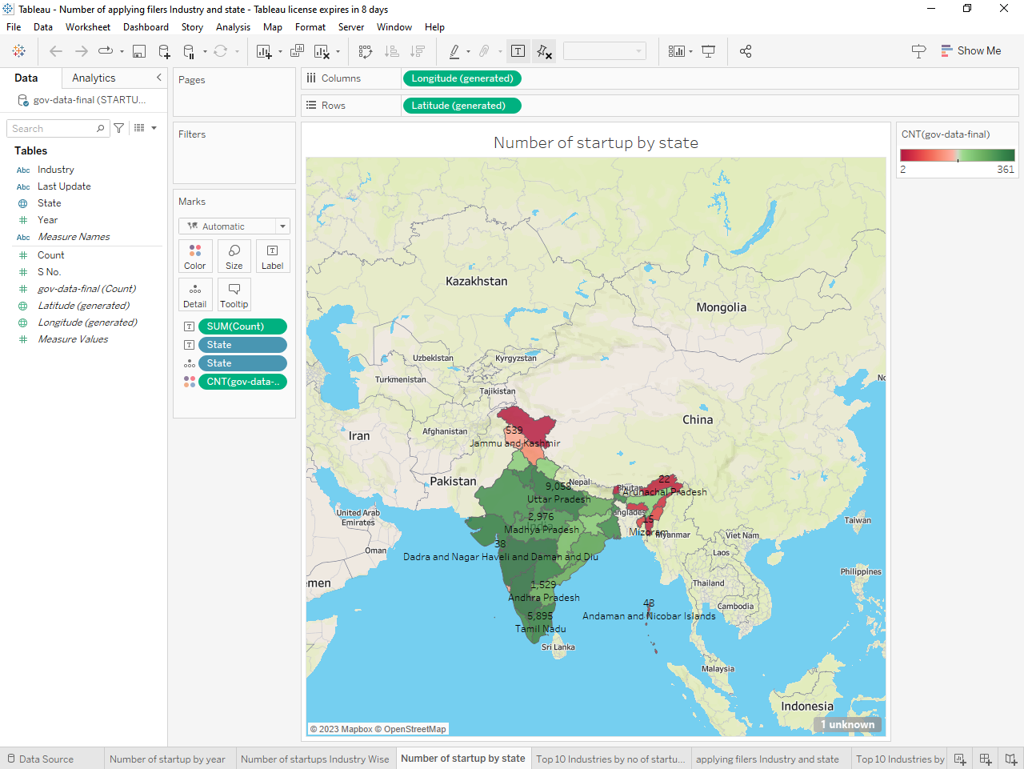

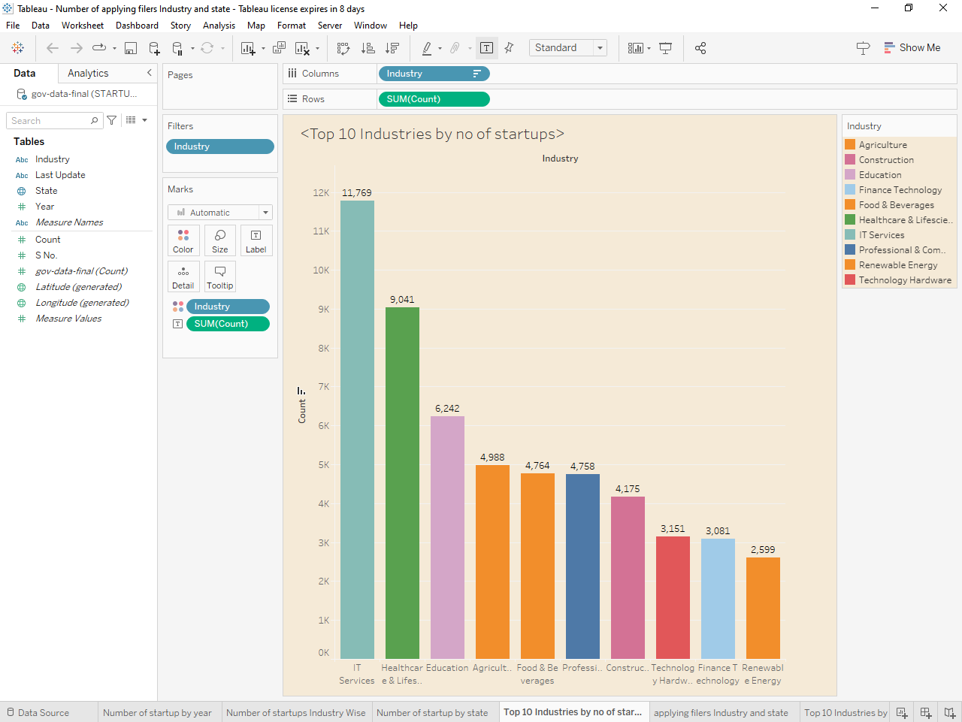

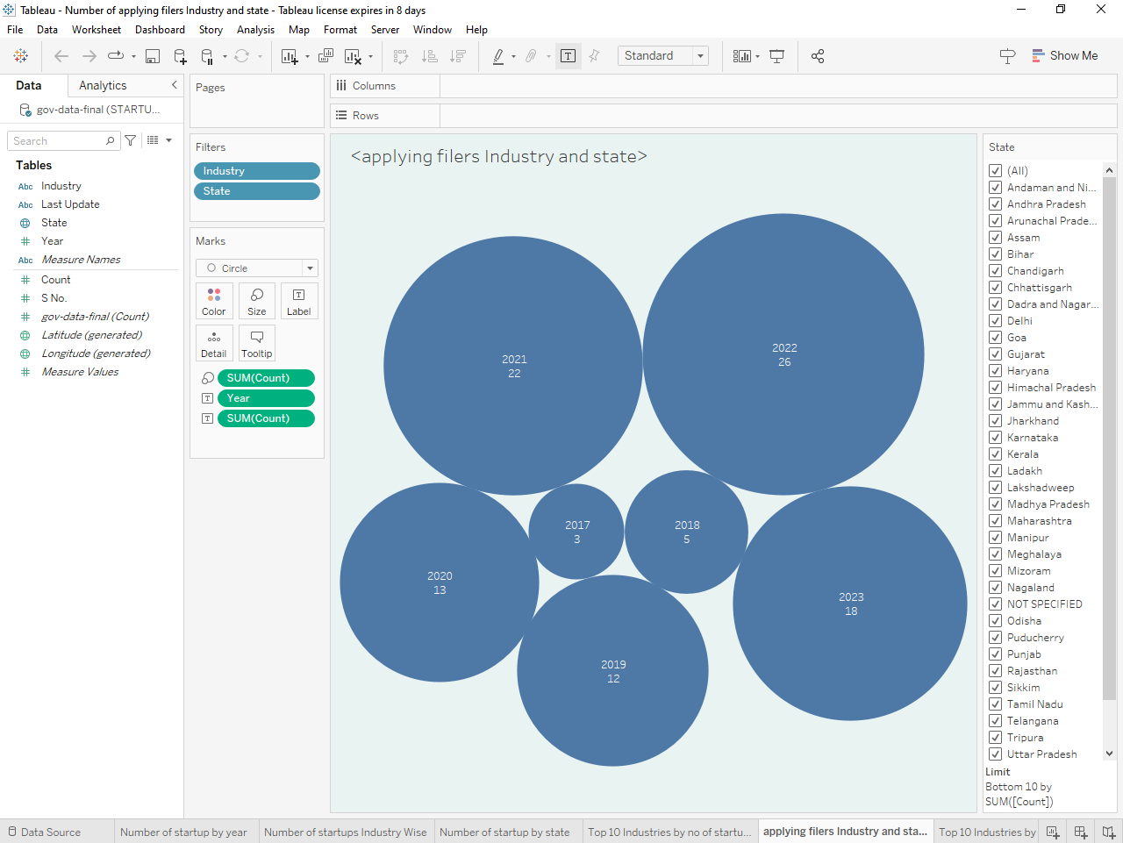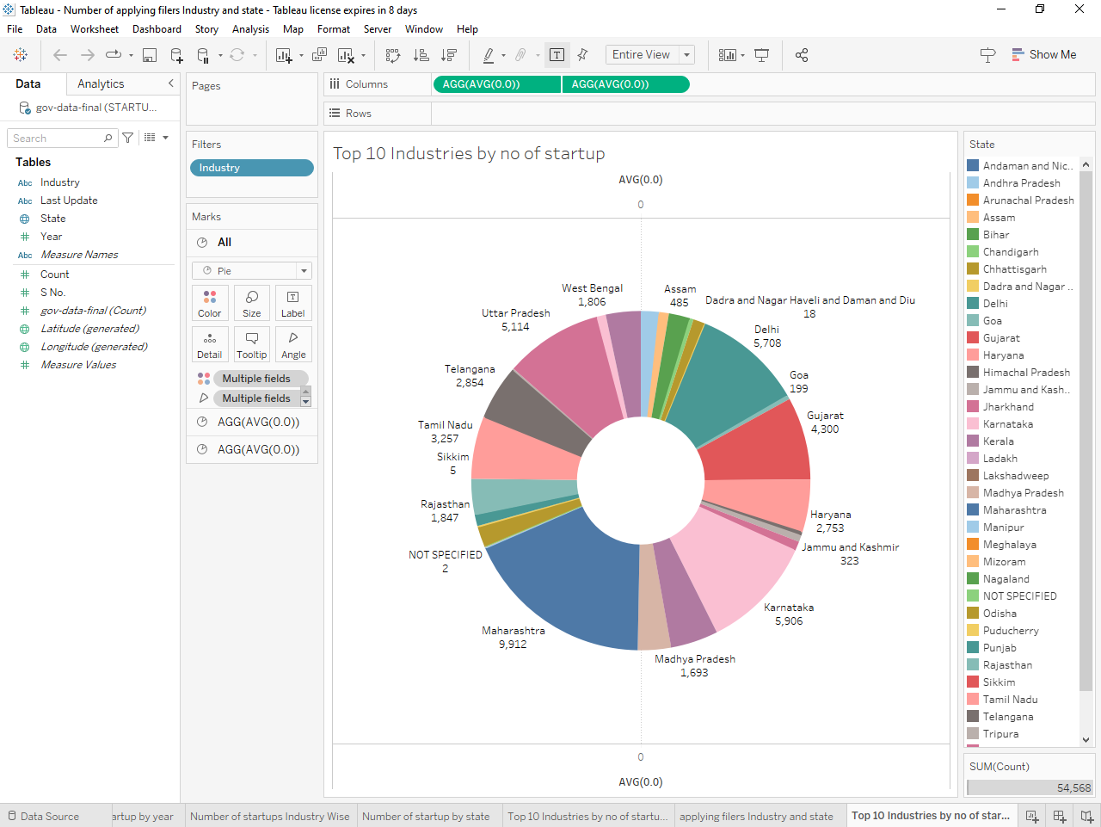 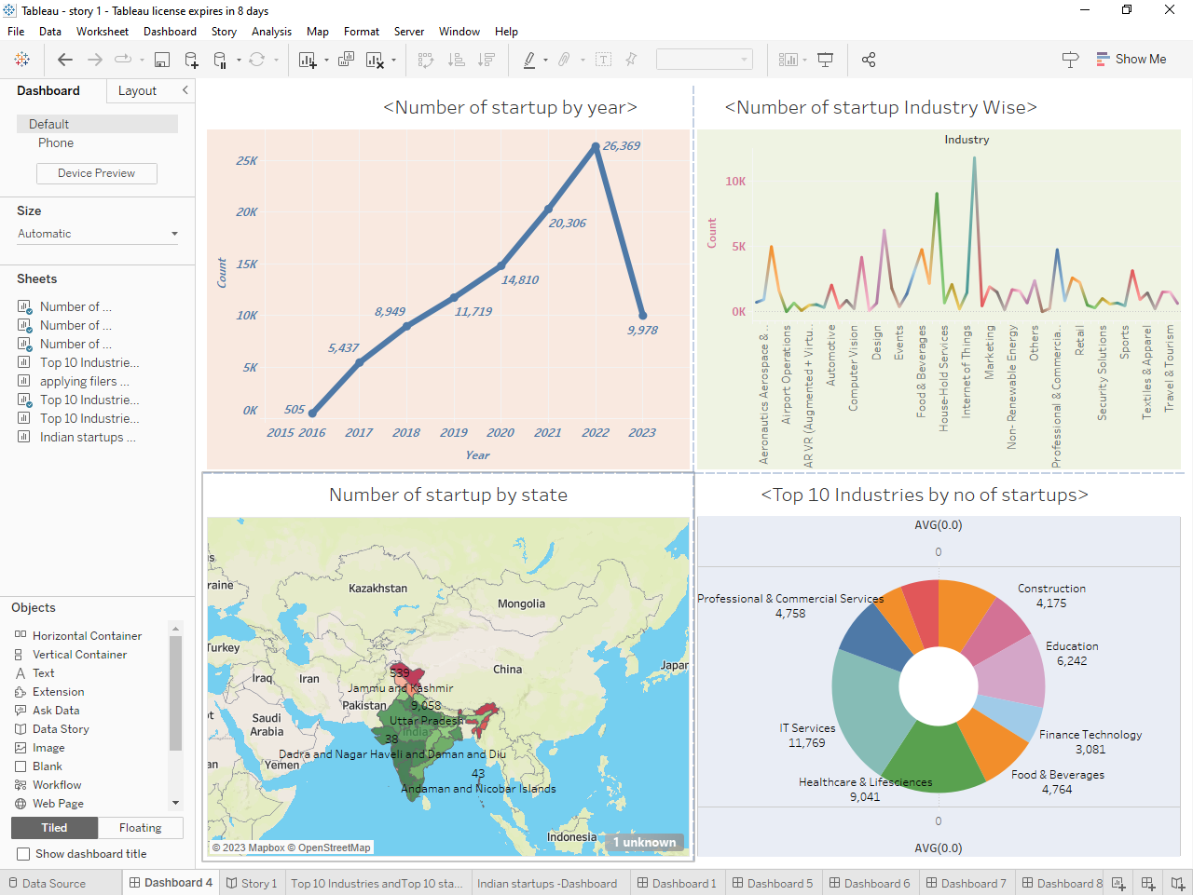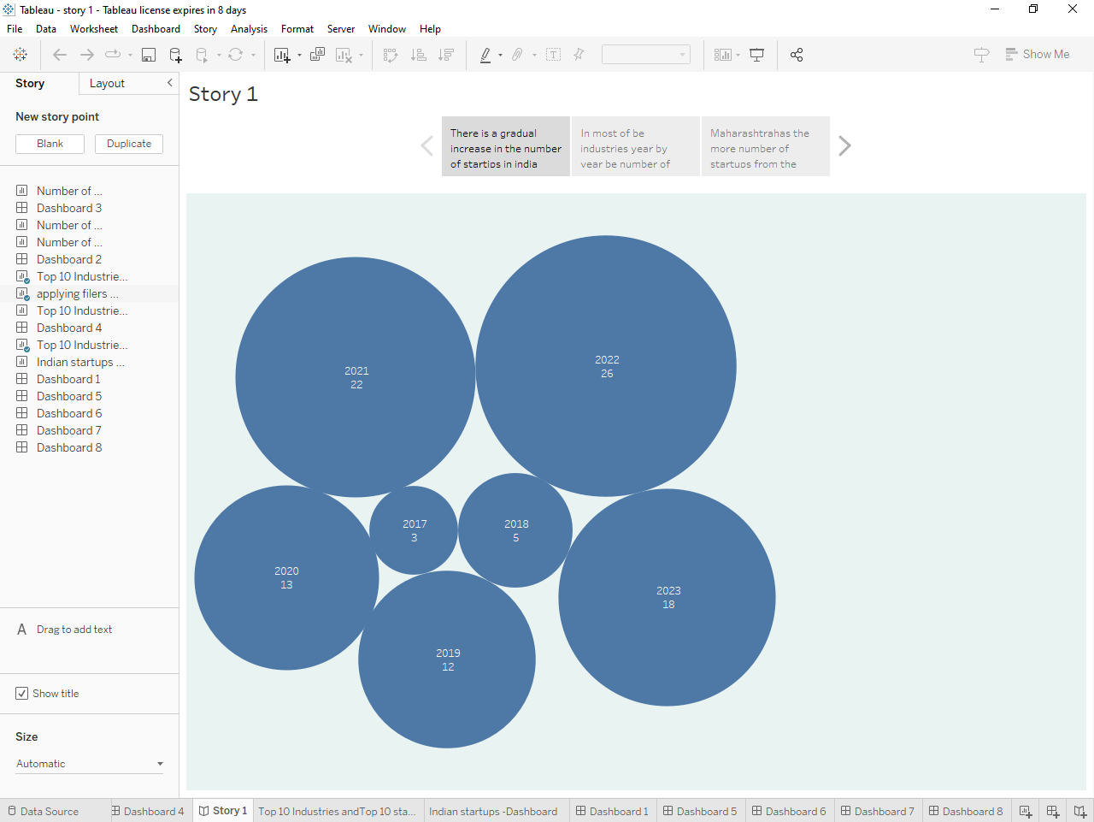

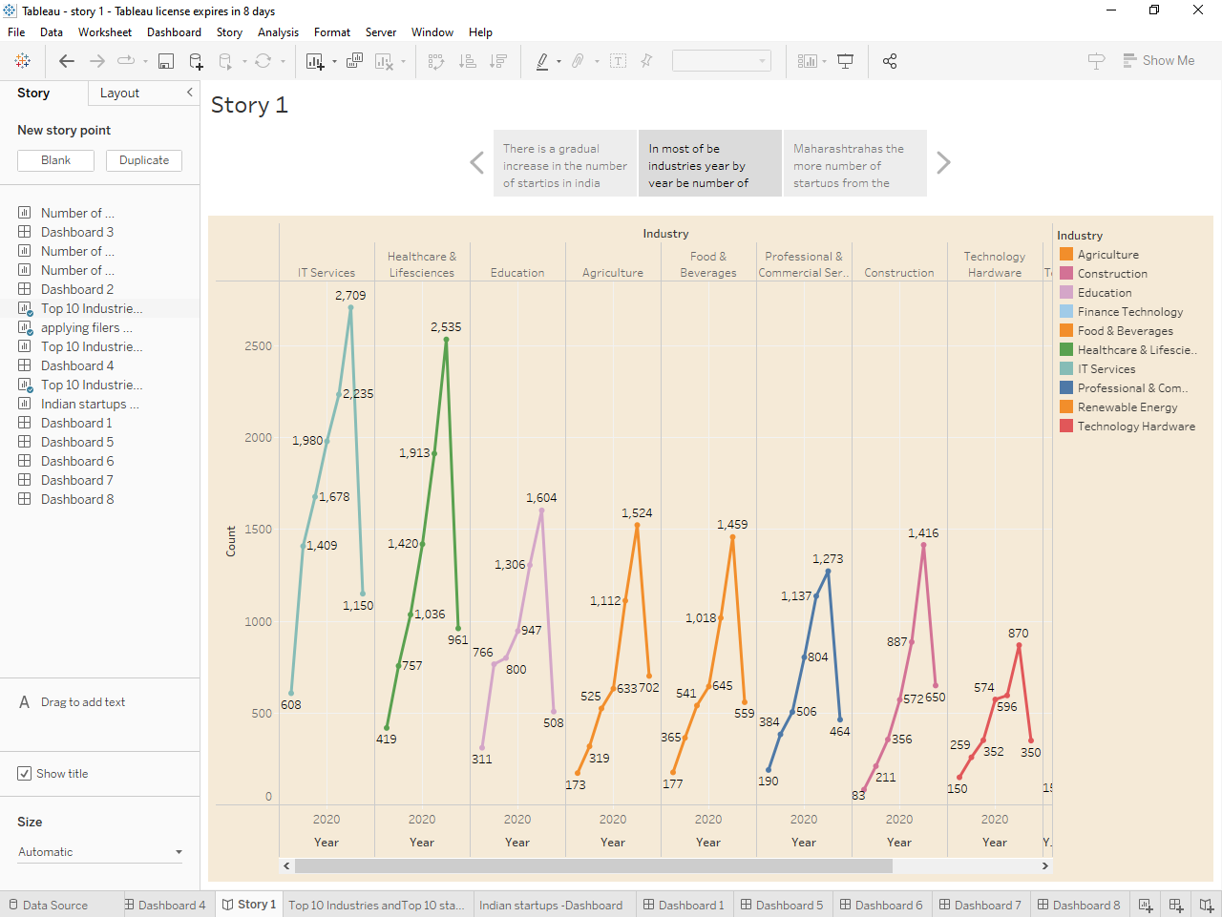

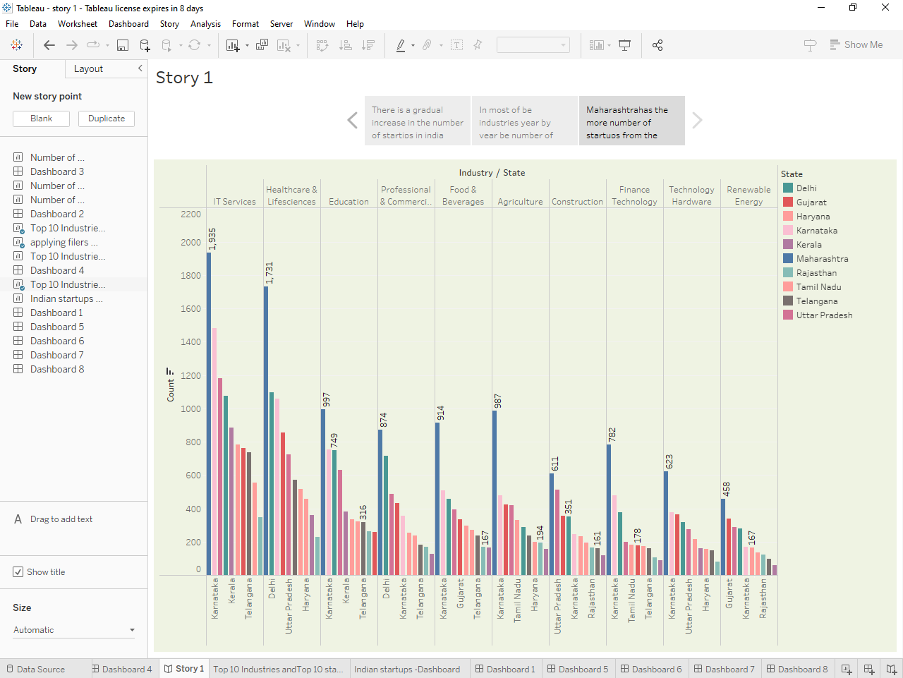

1. **Advanysges & Disagavantages**

Advantages:

1. Clarifying the weaknesses of your competitors.
2. Weighting your competitor ‘s strength.
3. Marketing potential forecasting.
4. Getting to know your business well.
5. Understanding the market.

Disadvantages:

1.Uncertain job security.

2.A heavy workload.

3.Lask of structure.

4.Limited resources.

5.There will be no fixed working hours.

5 . Applications

1. Startups are companies or ventures that are focused on a single product or service that the founders wants to bring to market .These companies typically don ‘ t have a fully developed business model and ,more crucially, lack adequate capital to move onto the next phase of business .
2. Some startup programs like cortana,Microsoft oneDrive ,UpdatestartupUtility, windows security notification icon and more are ussally working in the background. These are always the windows built-in apps and services.

1. Conclusion

A business plan conclusion is a summary of a business plan’s strengths designed to convince the reader of the company’s success. Because companies typically create business plans to get funding or investors, the conclusion should focus on how the organization makes money and why it is a good investment.

1. Future

Scope Future scope of startup in India: Indian startups raised USD19. 3 billion across 1,456 deals in Ventures Capital(VC) between January 2021 and October 2021, against USD27. 5 billion across 1,355 deals between January 2022 and October 2022. In addition, startups in India are expected to raise USD180 billion in 2023.

8.Apphttps

1. <https://public.tableau.com/views/dashboard_16828469641400/Dashboard3?:language=en-US&publish=yes&:display_count=n&:origin=viz_share_link>

2. <https://public.tableau.com/views/story2_16830079439400/Story1?:language=en-US&publish=yes&:display_count=n&:origin=viz_share_link>